

CMPG 325 Computer Networks
Network Design & Implementation
Milestone 1: Client Design Review

Client: Lesedi Renewable Energy Research Group (Mahikeng)
Client ID: CLI-109 | Project ID: CMPG325-2026-109
Assigned Addressing Block: 172.30.74.0/23
Assigned Challenge: Router-on-a-Stick
Prepared by: L.I Phiri – 36151262 | Date: 22 August 2026

- Client Requirements

Lesedi Renewable Energy Research Group is a research organisation based in Mahikeng. Requirements below are directly drawn from the assignment brief for CLI-109 and are traced to their source, so nothing has been added beyond what the brief specifies.

Ref | Requirement | Source / Justification
1 | Network must use the assigned address block 172.30.74.0/23 for all internal addressing. | Assignment brief, fixed allocation for CLI-109
2 | Traffic must be logically segmented by function (research staff, administration, servers/lab equipment) to contain broadcast domains and separate research data from general office traffic. | Inferred from client being a research organisation with distinct staff and lab/server functions; standard practice for a research network handling project data.
3 | Inter-VLAN communication must be routed through a single router using sub-interfaces (Router-on-a-Stick), one sub-interface per VLAN on an 802.1Q trunk. | Assigned technical challenge, mandatory, intermediate difficulty.
4 | After-hours cleaning and security contractors require wireless network access, but that access must be limited (not full access to research/admin/server resources). | Client change request, explicit wording: “limited wireless access”, so scope is restricted to what this phrase requires.
5 | No new cabling may be run through the building's external walls. | Heritage-listed building constraint. Any new connectivity (for example, for the guest wireless AP) must use existing internal cable paths/risers or be delivered wirelessly from an AP fed by existing internal cabling.
6 | The design must be fully implementable and testable in Cisco Packet Tracer, producing a working .pkt file. | Assignment deliverable requirement.
7 | End-to-end connectivity must be demonstrated: intra-VLAN connectivity for all staff, inter-VLAN connectivity where appropriate (for example, the staff to servers), and correctly restricted connectivity for the guest VLAN. | Assignment testing requirement + Ref #4 (limited access implies some paths must fail by design).

1.1 Scope boundary
The client change request is worded specifically as “limited wireless access” for after-hours contractors and not general guest Wi-Fi, not staff mobility, and not a public hotspot. The design below is deliberately scoped to that wording.
In scope (per brief wording) | Explicitly out of scope for this project
VLAN segmentation, Router-on-a-Stick inter-VLAN routing, a wireless AP delivering restricted guest access, IP addressing from 172.30.74.0/23, and evidence/testing. | Additional VLANs, additional sites, full NAC / 802.1X guest portal, redundancy/HA routing (HSRP/VRRP), dynamic routing protocols, and any wired guest network and none of these are asked for in the brief and are intentionally not added, to avoid unnecessary scope.

2. Physical Topology
The physical design uses a single router performing Router-on-a-Stick inter-VLAN routing, a core switch, two access switches (one per functional wing of the building), server-room end devices connected directly to the core switch, and one indoor wireless access point serving the restricted guest/contractor VLAN.
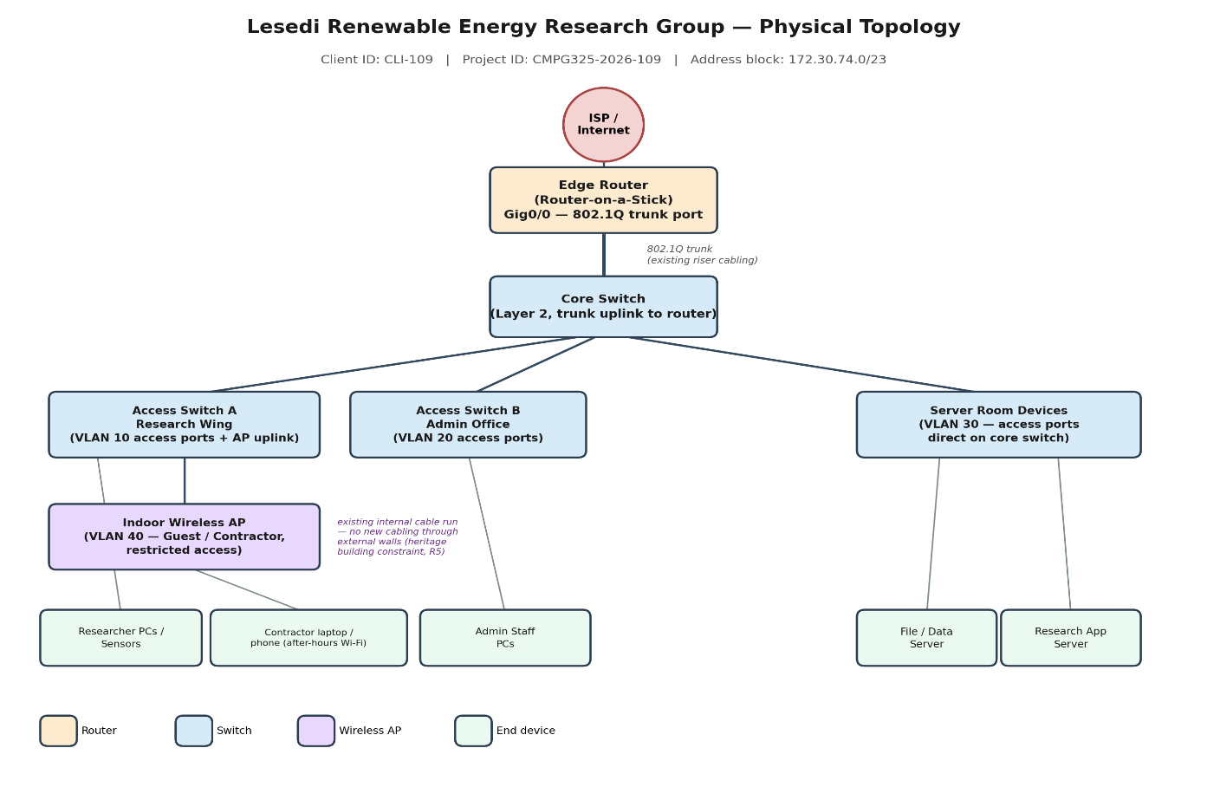

2.1 Devices
Device | Role | Notes
1x Router (e.g. Cisco 1941/2911) | Router-on-a-Stick, inter-VLAN routing | Single physical link (Gig0/0) to core switch, configured with 5 sub-interfaces (.10 .20 .30 .40 .99), each an 802.1Q encapsulated gateway.
1x Core Switch (Cisco 2960) | Trunk aggregation | Trunk port to router; trunk/access ports to access switches, server room devices and AP.
2x Access Switches (Cisco 2960) | Access layer | Switch A (Research wing): VLAN 10 access ports + uplink for the wireless AP. Switch B (Admin office): VLAN 20 access ports.
1x Wireless Access Point (e.g. Cisco Aironet / WRT300N in PT) | Guest/contractor wireless | Connected to an existing internal access-switch port (VLAN 40 access port). No new cable runs through external/heritage walls, reuses existing internal cabling.
End devices | Researcher PCs, Admin PCs, Servers, contractor laptop/phone | Distributed across VLANs 10, 20, 30 and 40 as per the logical topology.

2.2 Heritage building constraint

The building is heritage-listed, so no new cabling may be run through external walls. This is addressed in two ways:
- The wireless AP for the restricted contractor/guest VLAN is mounted indoors and connected to an existing internal access-switch port using existing internal cabling and wireless coverage extends access into the building without any new cable penetrating an external wall.
- All other new connectivity (router–switch trunk, inter-switch links) is likewise routed through existing internal risers/conduits rather than through external walls.

Logical Topology

Five VLANs separate traffic by function. All inter-VLAN traffic is routed by the single router over one physical trunk link (Router-on-a-Stick), using one 802.1Q sub-interface per VLAN as the default gateway for that VLAN.

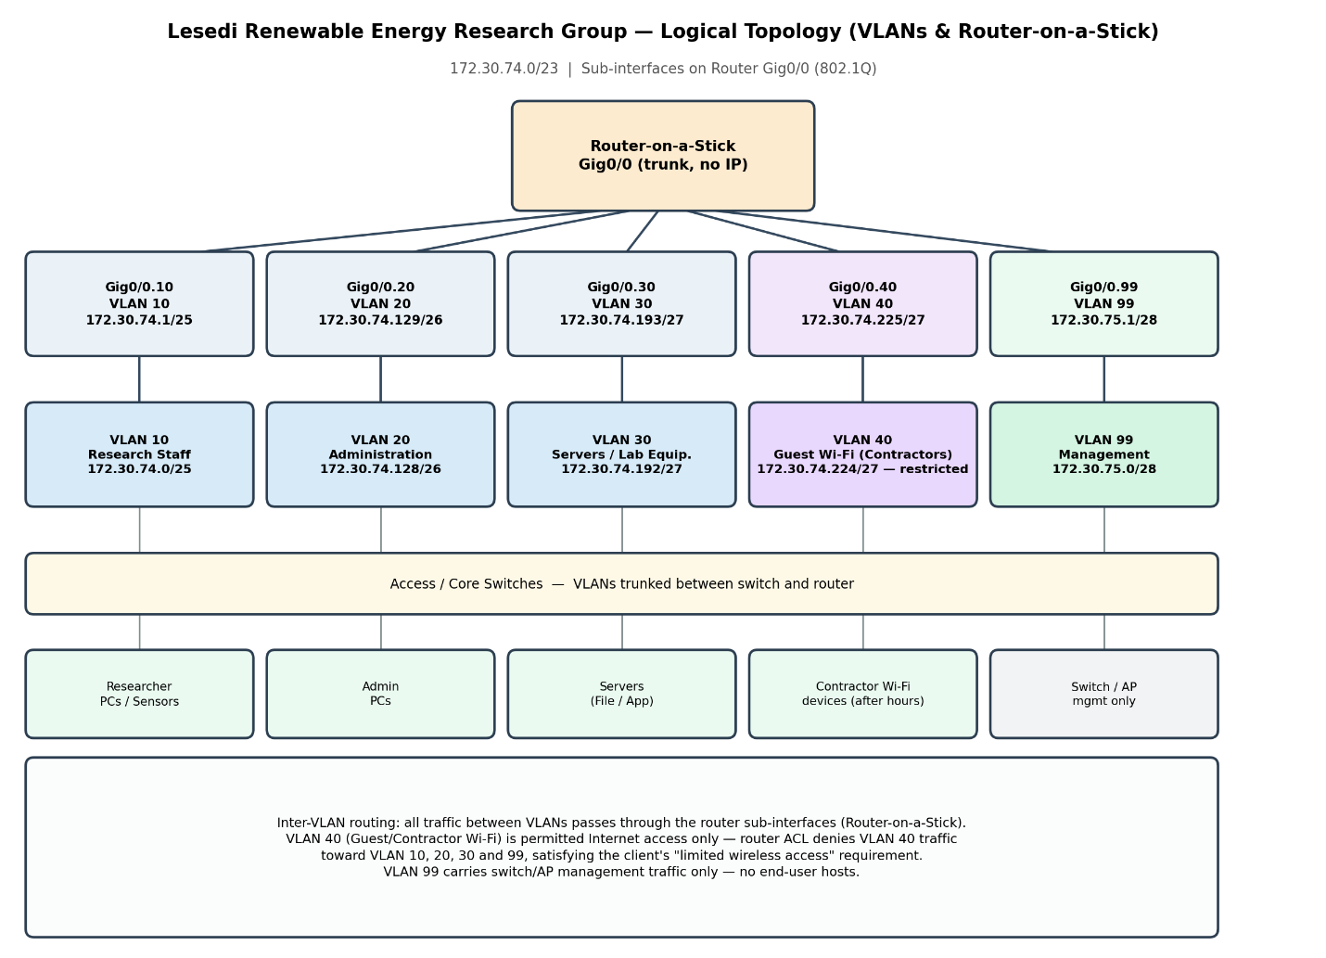

3.1 VLAN plan

VLAN | Name | Purpose | Subnet | Gateway | Usable hosts
10 | RESEARCH | Research PC’s data-collection/lab workstations | 172.30.74.0/25 | 172.30.74.1 | 126
20 | ADMIN | Administration & management staff | 172.30.74.128/26 | 172.30.74.129 | 62
30 | SERVERS | File/data server, research application server, lab equipment | 172.30.74.192/27 | 172.30374.193 | 30
40 | GUEST-WIFI | After-hours cleaning/security contractors (wireless restricted) | 172.30.74.224/27 | 172.30.74.225 | 30
99 | MGIT | Switch and AP management only (no end-user hosts) | 172.30.75.0/28 | 172.30.75.1 | 14

3.2 Why Router-on-a-Stick is appropriate here

Router-on-a-Stick is appropriate for this network because:
- The client is a single-site research group with a modest number of VLANs (five) and moderate traffic volumes. A single routed trunk link comfortably carries inter-VLAN traffic without needing a multilayer switch.
- It satisfies the assigned technical challenge directly: one router interface, sub-divided into logical sub-interfaces, each acting as the gateway for one VLAN.
- It keeps the design inexpensive and simple to verify in Packet Tracer, while still meeting the segmentation (Ref #2) and inter-VLAN routing requirements.

3.3 How restricted guest access will be enforced

VLAN 40 (Guest-Wi-Fi) hosts obtain the Gig0/0.40 sub-interface (172.30.74.225) as their gateway like any other VLAN, but the router will carry an access control list on that sub-interface that permits traffic out to the Internet/ISP only and denies traffic destined for VLAN 10, 20, 30 or 99. This will be configured and verified in the implementation milestone; it is noted here because it directly shapes the logical topology and IP plan (VLAN 40 is a distinct, isolated subnet for exactly this reason).

4. IP Addressing Plan

The assigned block 172.30.74.0/23 (172.30.74.0 – 172.30.75.255, 512 addresses) is subdivided using VLSM so each VLAN gets a subnet sized to its expected host count, with spare space kept for future growth rather than allocating the whole block immediately.

Subnet (CIDR) | Network Address | Usable Range | Broadcast | Assigned To
172.30.74.0/25 | 172.30.74.0 | 172.30.74.2 – 172.30.74.126 | 172.30.74.127 | VLAN 10 – Research
172.30.74.128/26 | 172.30.74.128 | 172.30.74.130 – 172.30.74.190 | 172.30.74.191 | VLAN 20 – Admin
172.30.74.192/27 | 172.30.74.192 | 172.30.74.194 – 172.30.74.222 | 172.30.74.223 | VLAN 30 – Servers
172.30.74.224/27 | 172.30.74.224 | 172.30.74.226 – 172.30.74.254 | 172.30.74.255 | VLAN 40 – Guest Wi-Fi
172.30.75.0/28 | 172.30.75.0 | 172.30.75.2 – 172.30.75.14 | 172.30.75.15 | VLAN 99 – Management
172.30.75.16 – 172.30.75.255 (remaining) | — | — | — | Reserved for future growth (not allocated)

4.1 Sizing rationale

- VLAN 10 (Research) is sized as the largest (/25, 126 hosts) as the primary functional group and researcher workstations and lab/data-collection PCs.
- VLAN 20 (Admin) uses a /26 (62 hosts), adequate for administrative staff with headroom.
- VLAN 30 (Servers) and VLAN 40 (Guest Wi-Fi) each use a /27 (30 hosts) and small, well-defined populations.
- VLAN 99 (Management) uses a /28 (14 hosts) and infrastructure only, no end-user devices.
- Roughly half the /23 block (172.30.75.16 onward) is left unallocated for future departments, additional lab equipment, or a wired guest option, without needing to renumber the existing VLANs.

5. Initial GitHub Repository
A GitHub repository has been created to hold professional evidence for this project as it develops across milestones. The initial structure and README are included as a companion file (README.md) alongside this document, ready to push as the first commit.

5.1 Planned repository structure
- README.md: project overview, client summary, and links to each milestone's evidence.
- /requirements: client requirements traceability (this document, extracted).
- /design: physical and logical topology diagrams, design rationale.
- /ip-addressing: VLSM addressing plan and subnetting workings.
- /packet-tracer: the .pkt file(s), versioned as the build progresses.
- /configuration: exported device configs (router sub-interfaces, switch VLAN/trunk config, AP/WLC config).
- /testing: ping/traceroute evidence, VLAN and trunk verification (show vlan, show interfaces trunk, show ip route).
- /screenshots: topology screenshots and simulation-mode packet captures.
- /troubleshooting: issues encountered and how they were resolved.
- /reflection: final write-up reflecting on the design and challenge.
- /CMPG 325 Documentation: holding the milestone submissions for the whole project.

5.2 Commit practice
Commits will be made incrementally as each milestone is completed rather than as a single final upload, so the commit history shows genuine development over time.

6. Summary
This Milestone 1 submission establishes: the client requirements (Section 1), a physical topology that respects the heritage no-external-cabling constraint (Section 2), a logical topology built around Router-on-a-Stick inter-VLAN routing with a deliberately isolated and restricted guest VLAN for after-hours contractors (Section 3), a VLSM IP addressing plan carved from 172.30.74.0/23 (Section 4), and an initial GitHub repository structure ready for iterative, evidenced development (Section 5). Subsequent milestones will implement this design in Cisco Packet Tracer, configure and verify the router sub-interfaces and ACL, and capture testing evidence.

